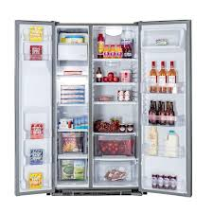

KLUGMANN

* Gross Capacity: 643L
* Energy Class: A+
* Color Stainless
* Shelves Tempered Glass
* **Rs.86,530**